25th Annual Celebration

Dr. Martin Luther King, Jr. Day

Embrace Unity: Be the Change!

Monday, January 15, 2018, 6:30PM, Art display 5:30PM
Lewisville High School Auditorium
1098 W. Main St., Lewisville, TX

Keynote Speaker:  Mr. Michael Brundy  Speaker, Author, Motivator | Art, Essay & Photo Contests Winners Announced  4th-12th Grade Students  Awards from $25 to $250
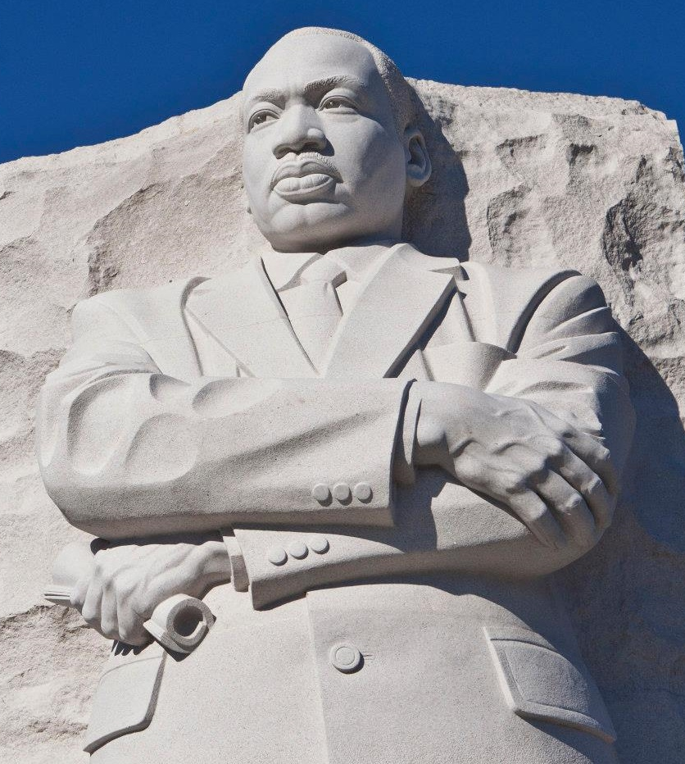
Entertainment: Downing Middle School Orchestra, Presentation of Colors by Boy Scouts from Westside Baptist Church, Voices of Tau Rho Omega, Chin Choir and “A Tribute to Dr. King” by Students from All LISD High Schools

Admission: Canned Goods for CCA will be appreciated.

For Information: (972) 410-3682 or www.MLKofNorthTexas.org

Sponsors: The Town of Flower Mound, The City of Lewisville, Lewisville Independent School District, Bahá'ís of Flower Mound, Tau Rho Omega Chapter of Alpha Kappa Alpha Sorority, Inc., The Greater Denton County Chapter of The Links, Inc., Rho Nu Lambda Chapter of Alpha Phi Alpha Fraternity, Inc., Davoodi Family Medicine, Vernell Gregg, Supercuts of Flower Mound-Lewisville, Dr. Patrick Shovlin, Saberre Law Firm, Mark Saunders and Joan Parks-Saunders, R.L. and Brenda Crawford, JoAnn Weaver, Minuteman Press and Rembert Custom Builders, AAA Club of Lewisville high School.

