SAVE THE DATE
FMHS ROSETTES
5th ANNUAL 5K RUN
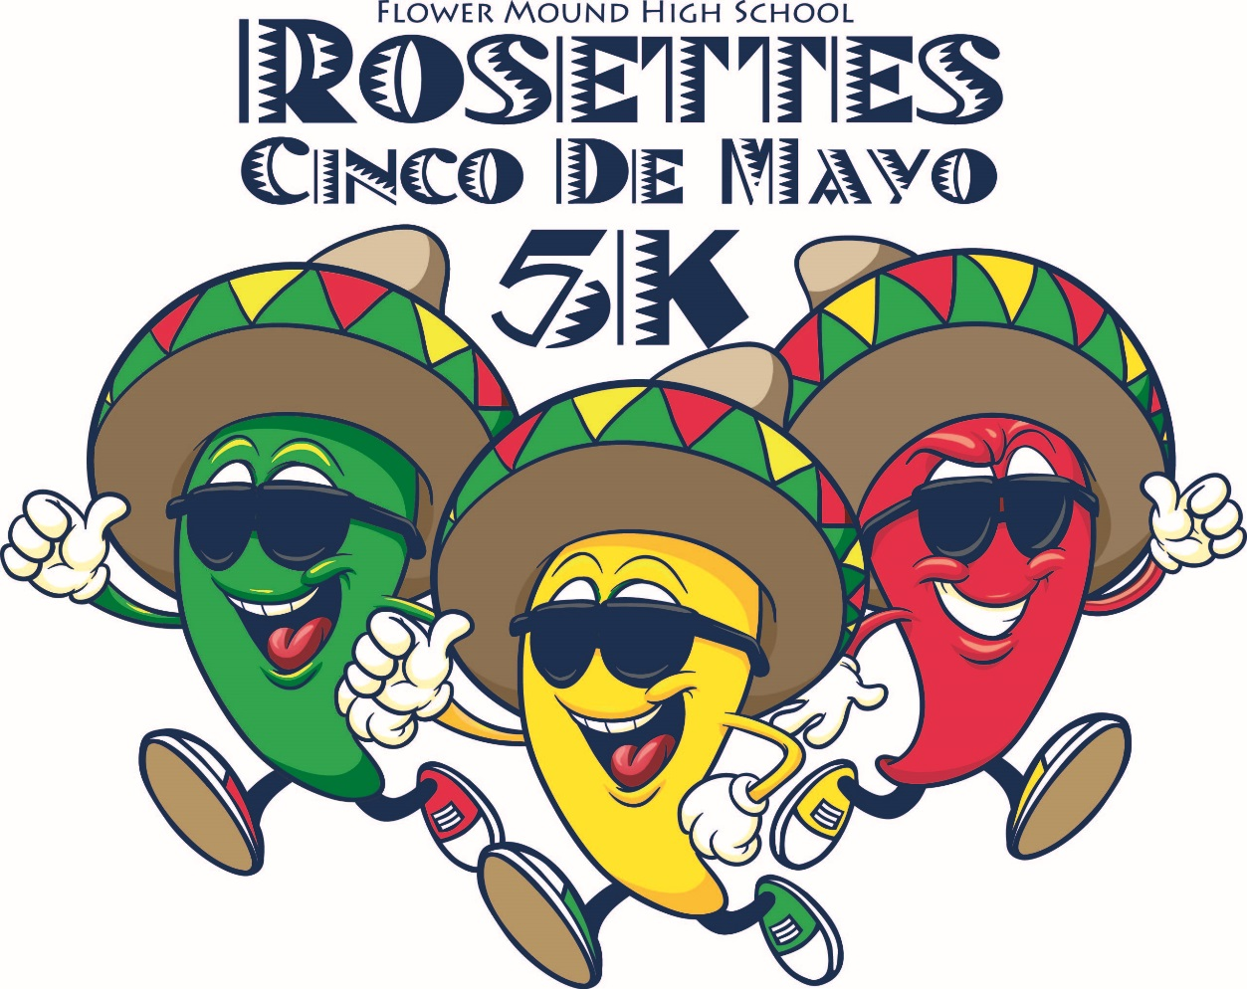
MAY 5TH, 2018
1ST, 2ND AND 3RD place medals will be awarded

Register at FMHSROSETTES.COM

