 | 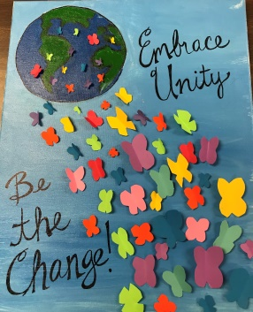 | 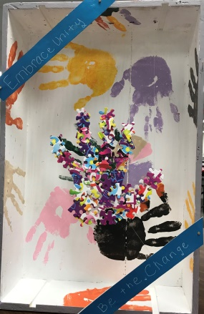 |  | 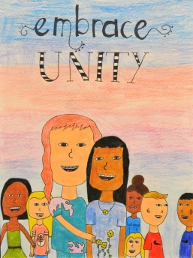
Izma Fias, Liberty, Ms. Ducote/Ms. Echols | Ellie Nelson, Homestead, Ms. Price | Lilah Hardin, Vickery, Ms. DiSalvo/Mrs. Jackson | Aanya Nuna, Wellington, Ms. Mitchener | Sarah Andrews, Heritage, Ms. Buchanan
 | 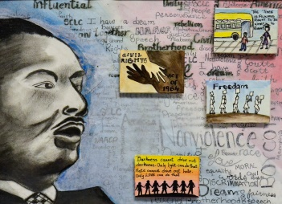 | 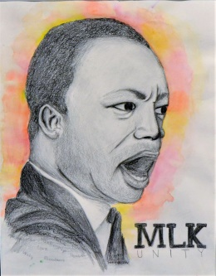 | 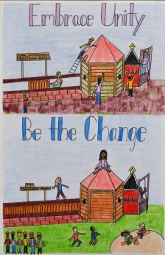 | 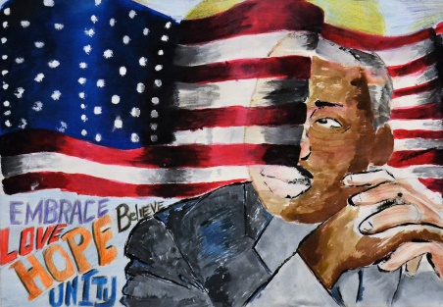
Eric Jeon, Rockbrook, Ms. Kistner | Vidhi Jadeja, McKamy, Ms. Cox | Lauren Jones, Creek Valley, Ms. Brazell | Nithika Koka, McKamy, Ms. Cox | Kennedeigh Smith, Lakeview, Mensfield
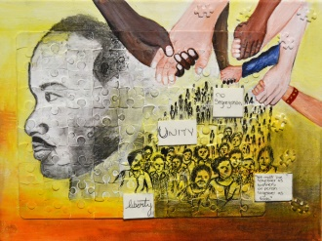 | 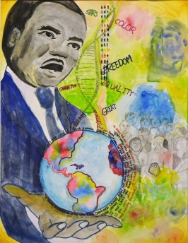 | 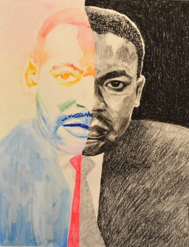 | 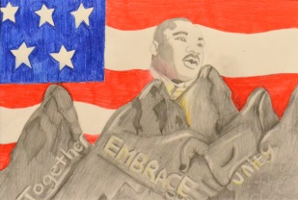 | 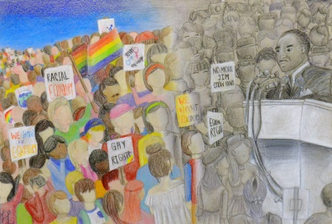
Riya Jadeja, McKamy, Ms. Cox | Youngju Paek, McKamy, Ms. Cox | Yiru Zhou, McKamy, Ms. Cox | Josephine Hibel, Lakeview, Mr. Mennsfield | Hannah Lee, Lamar, Ms. Neibert
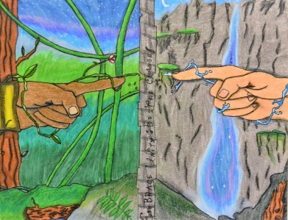 | 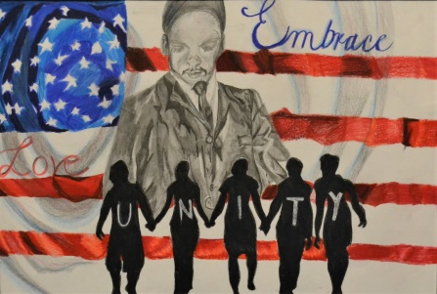 | 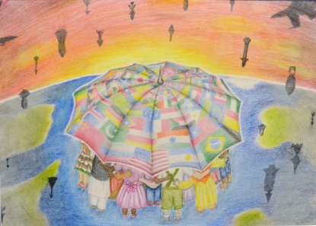 | 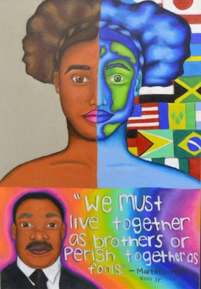 | 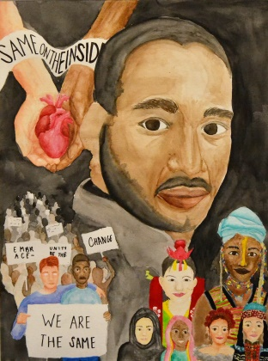
Israel Morales, Delay, Ms. Shaw | Summer Wayne, Lakeview, Mr. Mennsfield | Diya Jones, FMHS, Ms. Kucuk | Tamyra Kelly, Marcus, Ms. Lawrence | Claire Song, Hebron9, Mr. Hines
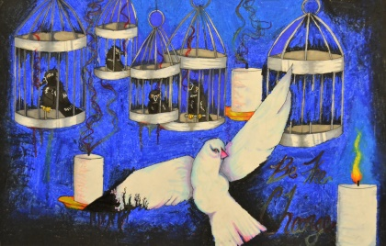 | 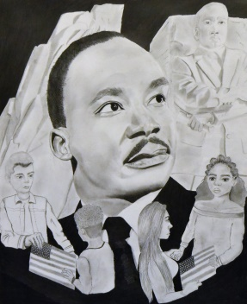 | 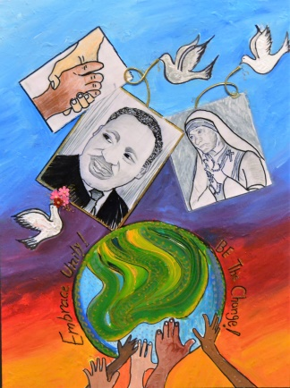 | 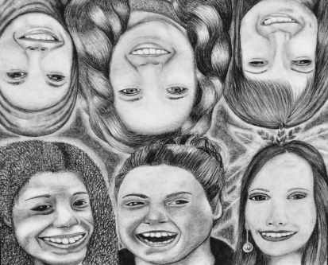 | 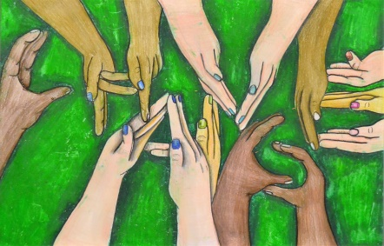
Kaitlin Acosta, Marcus, Ms. Bellevue | Chloe Johnson, Hebron, Mr. Hines | Ria Nuna, 10 FMHS, Ms. Harper | Reagan Starin, MHS, Ms. Bellevue | Caitlin Reimer, MHS, Ms. Lawrence
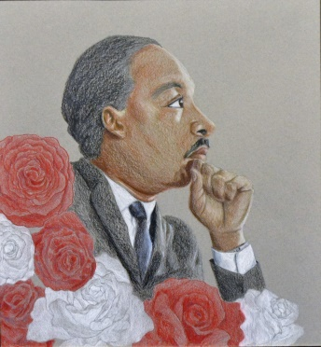 | 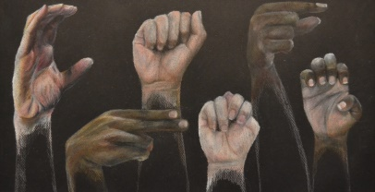 | 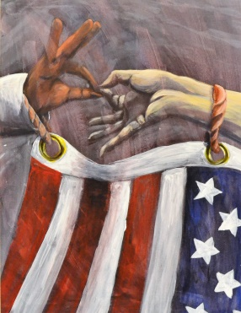 |  | 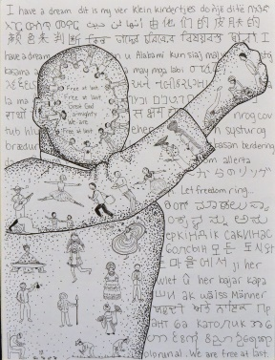
Evelyn Walker, MHS, Ms. Lawrence | Jun Kwon, FMHS, Ms. Harper | Abby Zechman, FMHS, Mr. Kruk | Emma Matochi, FMHS, Mr. Kruk | Catherine Tang, FMHS, Mr. Hyde
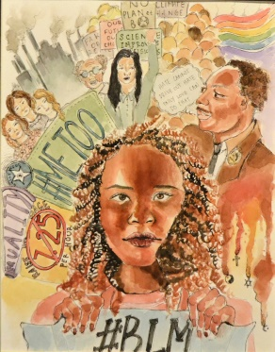 | 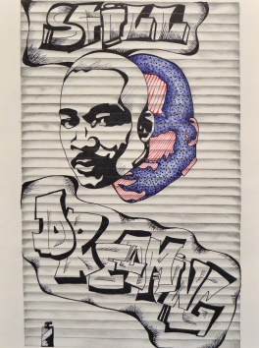 | 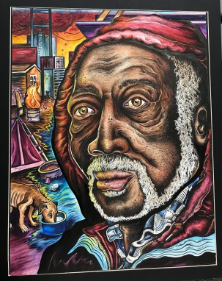 | 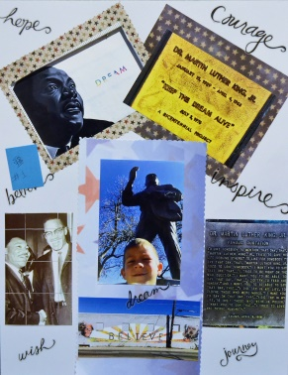 | 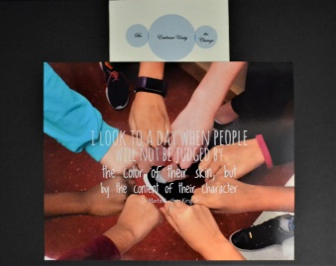
Michelle Fang, FMHS, Ms. Harper | Amber Ehmke, TCHS, Ms. Jones | Max Woods, FMHS, Mrs. Harper | Grayson McEuin, Prairie Trail, Clayton/Saucedo | Sydney Etufugh, Castle Hills, Ms. Etherly
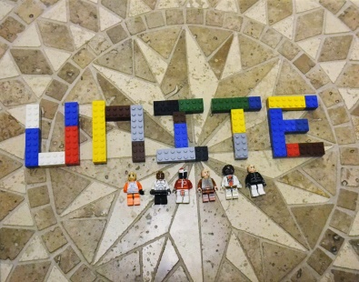 | 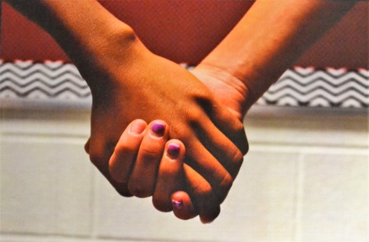 |  | 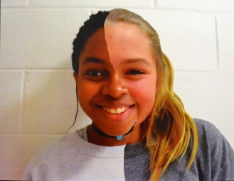 | 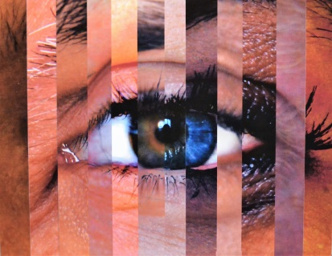
Shashank Chathapuram, Prairie Trail, Mr. Clayton | Madison Perez Luna, Downing, Ms. Mick | Madelyn Dudek, Downing, Ms. Mick | Mary Williams, Downing, Ms. Mick | Briana Banuelos, LHS Harmon, Ms. Jayme
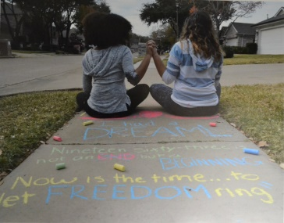 | 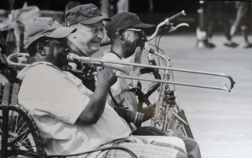 | 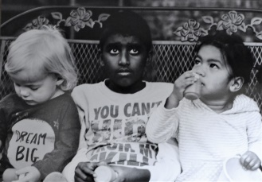
Alyssa Dean, MHS9, Ms. Miller | Lauren Foster, FMHS, Ms. McLeod | Leah Giesler, MHS, Ms. McLeod

